Scribble to Digital
Team ID :SWTID-2026-3995
Team Size : 5

Team Leader : POOJA B
Team Member : MADHUMITHA R
Team Member : PRASANNAVANI M
Team Member : BHUVANESHWARI B
Team Member : MONISHA B
Project Description :
Handwritten notes are widely used by students, teachers, and professionals to quickly record ideas, reminders, and important information. However, these notes can sometimes be difficult to read, organize, or store digitally, especially when the handwriting is unclear or the lighting conditions are poor. Converting such handwritten content into digital format often requires manual typing, which can be time-consuming and inefficient.
The Scribble to Digital system is designed to solve this problem by automatically transforming handwritten notes into well-structured digital text. Users can upload an image of their handwritten notes, and the system processes the image to improve its clarity. It then uses Optical Character Recognition (OCR) to identify and extract the text from the image.
After extracting the text, the system applies Generative AI to refine the content by correcting grammar, improving sentence structure, and organizing the information into readable paragraphs. Additionally, the system analyzes the text to identify important action items and converts them into a clear To-Do task list.
The application is built using Streamlit to create an interactive user interface, while Python is used to handle image processing, text extraction, and AI integration. This solution helps users quickly convert handwritten notes into organized digital content, making it easier to store, edit, and share information.
Use Case Scenarios :
Scenario 1: Uploading and Processing Handwritten Notes
In this scenario, a user uploads an image of handwritten notes through the application interface.
The system first processes the image to improve its quality. Image enhancement techniques are applied to make the text clearer and easier to read. These steps help remove noise, adjust brightness, and improve contrast so that the handwritten content becomes more visible.
Once the image quality is improved, the system sends it to the OCR module to detect and extract the written characters. This step helps convert the handwritten information into machinereadable text.
Output:
Enhanced image with improved clarity
Extracted handwritten text in digital form
Scenario 2: Text Refinement and Formatting
The text extracted from OCR may contain errors such as incorrect words, missing letters, or unclear sentence structures. In this scenario, the extracted text is processed by a Generative AI model to improve its readability.
The AI analyzes the context of the text and performs several improvements, such as correcting spelling mistakes, improving grammar, and restructuring sentences. It also organizes the text into properly formatted paragraphs so that the content becomes easier to read and understand.
Output:
Corrected and refined digital text
Well-structured paragraphs with improved grammar and clarity
Scenario 3 : Identification of Actionable Tasks
Handwritten notes often contain reminders, action items, or tasks mixed with general information. In this scenario, the AI system analyzes the processed text to identify sentences that indicate tasks or actions.
The system detects keywords and sentence patterns that represent tasks and separates them from normal text. These tasks are then organized into a clear list, helping users quickly identify important actions that need to be completed.
Output:
A structured list of extracted tasks
Clear separation between general notes and actionable items
Scenario 4: Digital Storage and Sharing .
After processing and organizing the content, the final digital notes can be stored in the system for future reference. Users can also download or share the notes in different digital formats. This allows easy access to the information from any device and simplifies collaboration with others.
Output:
Downloadable digital notes
Shareable document for easy access and collaboration
Architecture Overview :
Scribble to Digital is a smart web-based application that helps convert handwritten notes into organized digital text. The system is designed to simplify the process of transforming handwritten information into readable and structured digital content. It provides an easy-to-use interface where users can upload images of handwritten notes and receive a clean digital version of the text.
The application is developed using Stream lit, which provides an interactive and user-friendly interface for uploading images, processing data, and displaying results. The backend processing is handled using Python, which coordinates the different modules involved in the system.
To improve the quality of uploaded images, the system uses OpenCV for image preprocessing tasks such as noise removal, contrast enhancement, and grayscale conversion. These steps help increase the accuracy of text recognition.
The system then uses an OCR (Optical Character Recognition) engine, such as Tesseract or Easy OCR, to detect and extract text from the enhanced image. The extracted text is further processed using Generative AI with the Gemini model, which improves the text by correcting grammar, restructuring sentences, and organizing the content into readable notes.
Finally, the system presents the processed output to the user in a structured format, which may include cleaned digital text and an optional list of extracted tasks or action items. This architecture ensures efficient processing of handwritten notes and improves the overall usability of the application.
Core Technologies :
Streamlit: Used to build the web interface of the application. It allows users to upload images, start processing, and view the generated results in an interactive environment. Generative AI (Gemini Model): Used to improve the extracted text by correcting grammar, refining sentence structure, and identifying important tasks from the notes. OpenCV Library: Helps in image preprocessing by improving image quality through operations like grayscale conversion, noise reduction, and contrast enhancement.
OCR Technology (Tesseract or Easy OCR): Responsible for reading and extracting text from the processed handwritten images and converting it into machine-readable format. Python Programming Language: Acts as the main backend language that connects all components such as image processing, OCR, AI integration, and the user interface. Document Export Libraries: Tools such as PDF and Word document libraries are used to allow users to download the final digital notes in different file formats.
Pre-requisites :
- Google AI Studio Account – Required to create and use the Gemini API key.
- Python Installed – Python version 3.8 or higher should be installed on thesystem.
1. Streamlit Framework– Interface Needed to build and run the web application
- OCR Tool Setup – Install an OCR engine like Tesseract or EasyOCR for text recognition.
- Required Python Libraries – Install necessary libraries such as OpenCV, Pillow, and AI integration libraries.
6.Export Libraries – Tools like ReportLab and python-docx are required to generate PDF or Word files for downloading the final notes.
Project Workflow:
1. AI Model Setup and Configuration Step 1.1: Create Gemini API Access
Sign in or create an account in Google AI Studio.
Generate an API key to access the Gemini model.
Activate the Gemini model required for the project.
Test the API connection using a simple prompt to confirm it works properly.
Step 1.2: Environment Setup
Save the API key securely in a .env configuration file.
Use the python.env libraryto load the environment variables in the project.
Configure model settings such as response length, creativity level, and output format.
Verify that the API connects correctly with the Streamlit application.
Step 1.3: Prompt Creation for AI Processing Design prompts that help the AI improve extracted text.
Prompts are used for:
Correcting grammar and spellingo Improving sentence structure
Converting messy text into organized paragraphs
Create additional prompts to detect and extract tasks from the notes.
2. System Development
Step 2.1: Build Streamlit Application Layout
Organize the project into separate modules for better management. Design the main Streamlit interface including:
Application title and description
Image upload section
Processing buttons
Output display area.
Step 2.2: Image Processing Implementation
Allow users to upload handwritten images in formats such as JPG or PNG.
Use OpenCV to improve image quality by: o Converting images to grayscale o Adjusting brightness and contrast o Removing unwanted noise o Applying threshold filters
Display the processed image for user preview.
Step 2.3: Text Extraction Using OCR
Integrate an OCR tool like Tesseractor EasyOCR.
Extract handwritten text from the processed image.
Clean the extracted text by removing unwanted characters or symbols. Show the raw OCR output for comparison.
Step 2.4: AI-Based Text Enhancement
Send the extracted text to the Gemini AImodel. The AI performs:
Grammar correctiono Sentence improvement
Context-based word completion
Formatting into readable notes
The system also identifies action items and creates a separate task list.
3. User Interface Development
Step 3.1: Interactive Components
Implement interface elements such as: st.file_uploader() for uploading images st.image() for previewing images st.button() for triggering processing steps st.spinner() for loading indicators
st.text_area() for displaying extracted text.
Step 3.2: Result Display
The application displaysresults in different sections:
Enhanced Image
Raw OCR Extracted Text
AI Corrected Digital Notes
Automatically Generated To-Do Tasks
Optional features may include hiding the raw OCR output and enabling downloads.
Step 3.3: Export and Download Options
Allow users to export results in different formats.
Generate downloadable files such as:
PDF documents
Word documents
Provide download buttons for saving the processed notes.
4. Testing and Improvement
Step 4.1: System Testing
Test the system using different handwriting styles such as:
Clear handwritingo Poor or messy handwriting o Notes containing both text and tasks
Bullet-point lists.
Verify the accuracy of both OCRextraction and AI processing.
Step 4.2: AI Output Evaluation
Check the AI-generated contentfor:
Correct grammaro Logical sentence flow o Proper formatting Accurate identification of tasks.
Step 4.3: Performance Optimization
Improve image preprocessing efficiency.
Reduce unnecessary API usage to save processing time.
Implement error handling for cases such as image upload errors, OCR failure, or API issues.
Step 4.4: Export Verification
Confirm that generated PDF and Word files are correctly formatted. Ensure files open correctly on different devices.
Test downloads across multiple web browsers.
Milestone 1: AI Setup & Initialization
Objective:
Establish the AI backbone required to transform handwritten content into structured digital text using Google Gemini 2.5 Flash.
The system will:
Refine messy OCR output
Fix grammatical and spelling errors
Predict missing words using context
Identify actionable tasks
Convert handwritten notes into structured digital documents.

Activity 1.1: Gemini API Configuration
Step 1: Access Google AI Studio
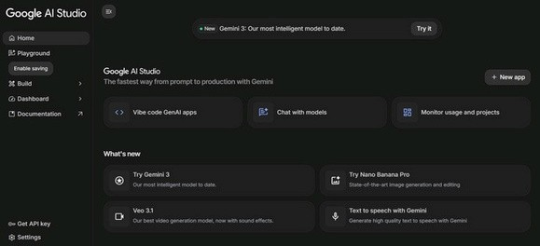
Open: https://makersuite.google.com/app/apikey
Sign in with your Google account Accept usage policies
Step 2: Generate API Key
Click “CreateAPI Key”
Copy and store securely
Save inside .env file
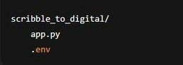
Add:
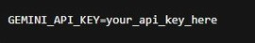
Step 3: Choose AI Model Selected Model: Gemini2.5Flash
Why this model?
Low latency
Cost-efficient
Optimized for text processing
Ideal for rewriting and structured extraction
Activity 1.2: Environment Setup
Required Libraries
Install dependencies:

Activity 1.3: API Testing
Create a simple test inside app.py:
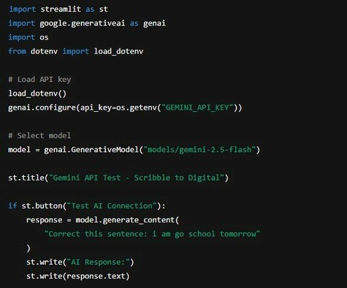
Test 1 – Sentence Correction
Input:
“tomorrow meting at 5 pls bring documnts”
Expected Result:
“Tomorrow’s meeting is at 5 PM. Please bring the documents.”
Test 2 – Task Extraction
Input:
“Finish assignment submit by friday call rahul” Expected Result:
Clean paragraph Extracted tasks: o Finish assignment o Submit by Friday o Call Rahul
Milestone 2: Application Development (Streamlit)
Objective:
Develop the complete working interface integrating OCR and AI.
Activity 2.1: Application Initialization
Create main file: app.py
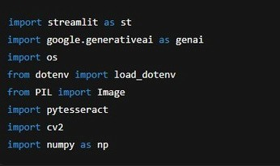
Configure model
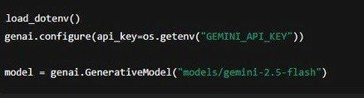
Activity 2.2: OCR Processing Module
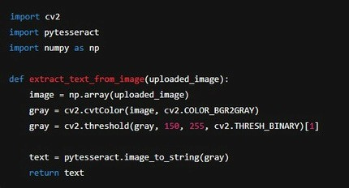
Convert image to grayscale
Adjust contrast
Remove background noise Extract raw text
Output: Unstructured OCR text
Activity 2.3: AI Text Processing Module File: ai_module.py
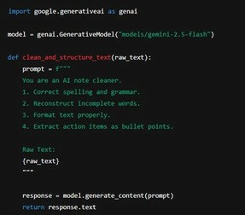
Correct grammar Input:
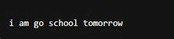
Expected Output:
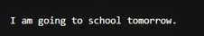
Improve clarity
Predict incomplete words Identify task-related phrases Output:
Clean digital notes
Separate to-do list
Activity 2.4: Stream lit UI Workflow
User Flow:
- Upload handwritten image
- Click “Convert”
- OCR extracts text
- Gemini refines content
- Structured output displayed
Activity 2.5: File Export
Export Options:
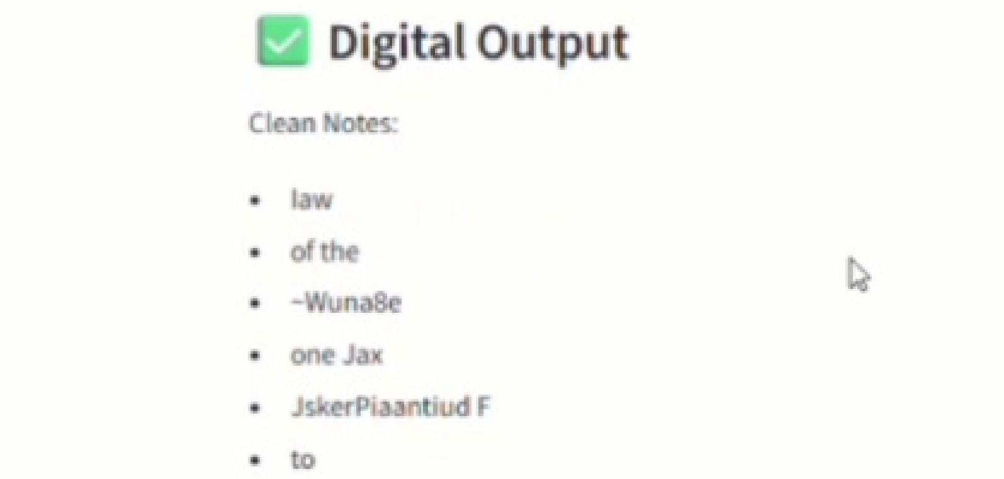
.txt for cleaned notes
.csv for task list
Future scope: PDF
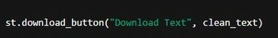
Milestone3: Flask Backend Integration
Objective:
Build a robust backend system with proper validation and modular design.
Core Backend Features
Input Validation
Accepts JPG, PNG, JPEG
Rejects empty uploads
File size restriction
Image readability verification

Example Response:
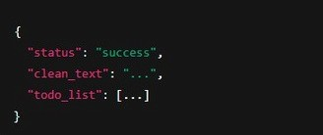
Modular Architecture
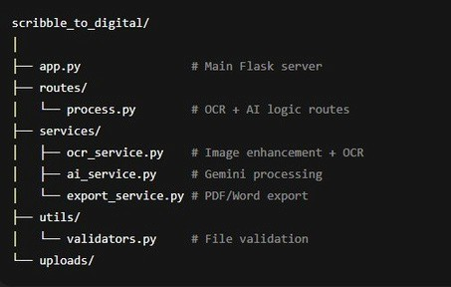
Export System
Supported Formats:
PDF with formatted sections
Word document (.docx)
CSV task tracker
File management Temporary Storage
Automatic deletion
Secure download handling

Milestone 4: Frontend Design (Streamlit UI)
Objective:
Design a modern, user-friendly interface.
Landing Page
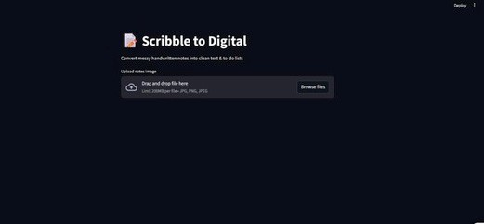
Title:
Digitize Your Handwritten Ideas with AI Features :
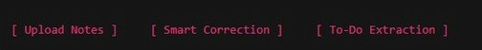
Upload Image
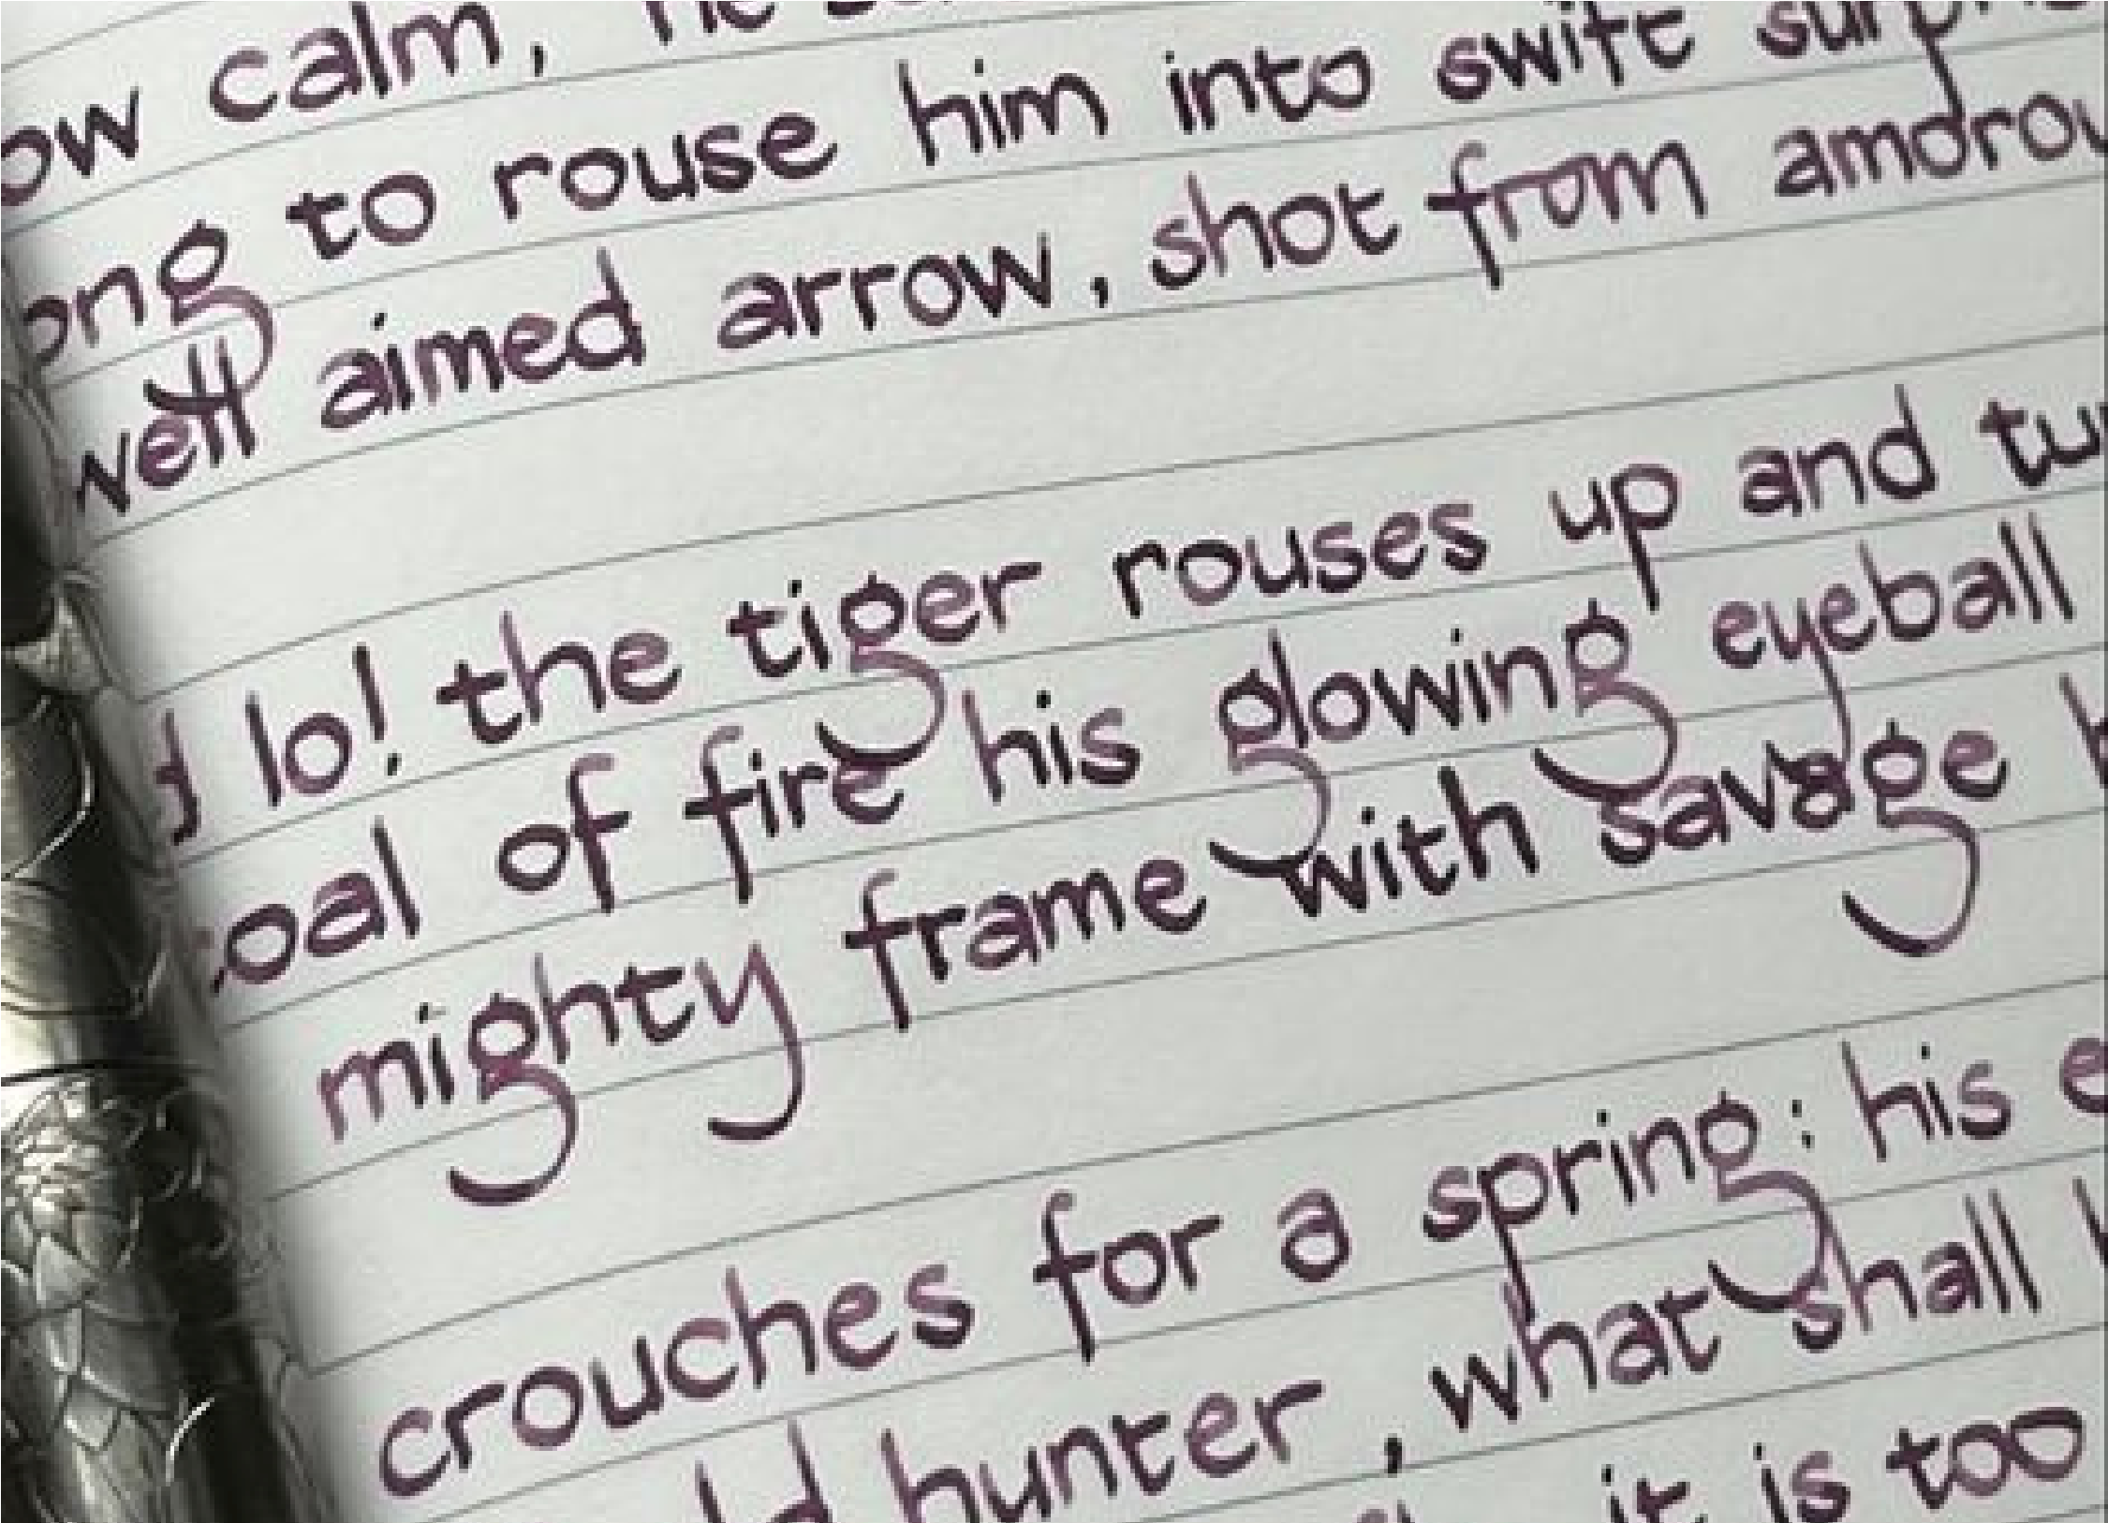
AI-Powered Correction
✔Automatic Task Detection
Processing Page Components:
Image uploader
Convert button
Reset option
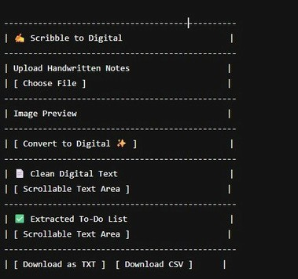
Export Section
Buttons:
Download Clean Notes
Download Task CSV User Feedback:
Loading spinner
Success message
Error alerts

Milestone 5: Testing & Optimization
Testing Cases Case 1 – Clear Writing
Result: High accuracy extraction and clean output
Case 2 – Moderate Quality
Result: Minor OCR errors corrected by AI
Case 3 – Blurred Image
Result: Partial recovery using preprocessing
Case 4 – No Tasks Present
Result: Displays clean notes and “No action items found” Quality Metrics
OCR precision rate
Grammar improvement score
Task extraction accuracy
Export formatting correctness
Optimization Techniques :
✔ Reduced API token usage
✔Improved image enhancement speed
✔Added loading indicators
✔Prevented duplicate processing ✔Handled API/network errors gracefully
Complete User Journey:
- Open application
- Upload handwritten note 3. Click Convert
- View :
Clean formatted text
Extracted tasks
- Download results
Conclusion :
The Scribble to Digital application successfully demonstrates how Generative AI and OCR technology can work together to transform handwritten notes into structured digital content. By integrating image preprocessing, Tesseract OCR, and Gemini 2.5 Flash, the system effectively converts messy handwritten text into grammatically correct and well-formatted digital notes.
The application not only enhances readability but also intelligently extracts actionable tasks, making it highly useful for students, professionals, and daily planners. The modular architecture using Streamlit and Flask ensures scalability, maintainability, and smooth performance.
Through comprehensive testing and optimization, the system proved to be stable, accurate, and user-friendly even under different image qualities and edge cases.
Overall, Scribble to Digital bridges the gap between traditional handwritten notes and modern digital productivity tools, showcasing the practical impact of Generative AI in real-world applications.

